BBC Wales Advertisement for Dylan Thomas Season
http://www.bbc.co.uk/programmes/p01t2jgt

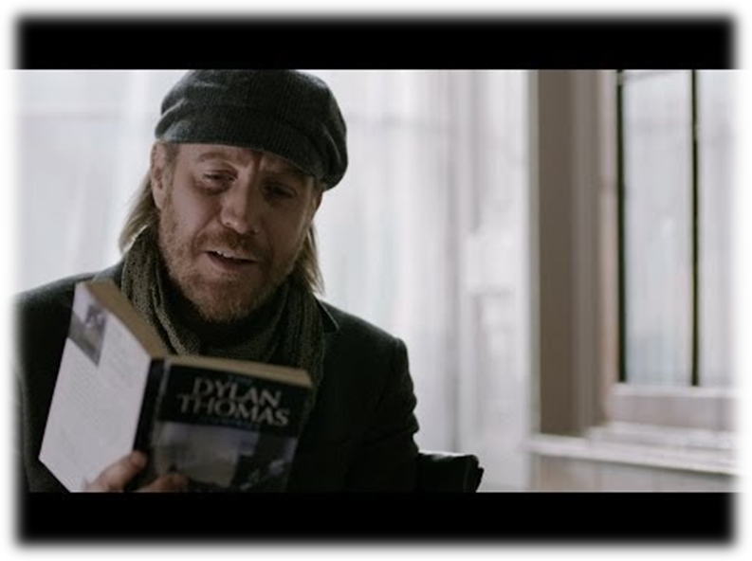

Benjamin Zephaniah reads Do Not Go Gentle Into That Good Night for his BBC1 programme, Ugly Lovely Swansea- A poet on the estate.
http://www.bbc.co.uk/programmes/p01xwkv6

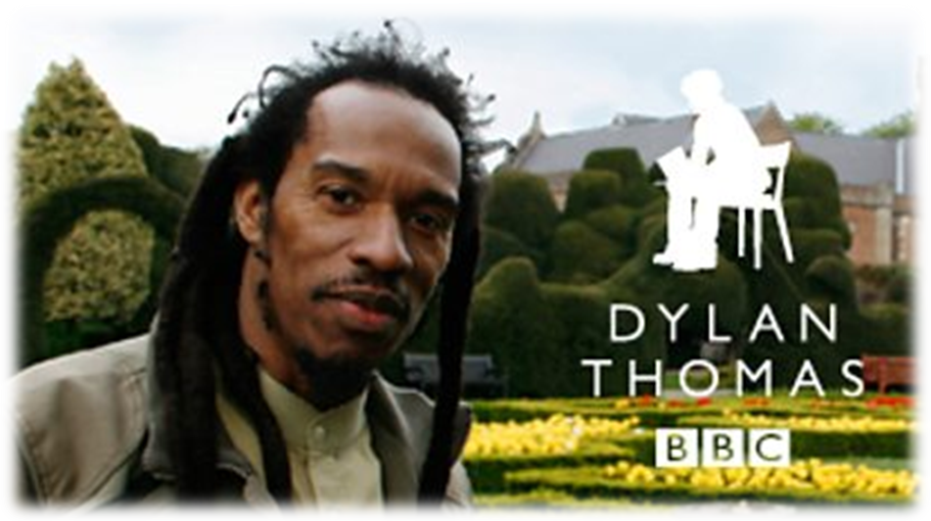

Teaching ideas
Watch Hannah Ellis’ interview where she talks about Dylan’s influences and inspiration, she speaks about how his “work is relevant…timeless…”. His works have been revisited and adapted in many different ways over the decades.

Do Not Go Gentle Into That Good Night is a complex work but when read aloud, its rhythm and pace make it easy to listen to and understand.

- What do you think it may be about and why did Dylan write it?

- Listen to the BBC Wales advertisement, (no visual). How effective are the voices?
- Then play again with the visual. Does it make a difference to your understanding of the poem? If so, how?
- How does it make you feel?

- Then listen to Zephaniah’s version and again with visual.

- Which do you think is the most effective and why? What are the differences in the way in which it is read?

- Having listened to them both, what do you think Dylan was writing about?

- Learners could do their own performance of the poem.
Will they read it solo or with a group of classmates? Which is more effective?
If it was filmed, what sort of background should be used?

